**MYSQL ASSIGNMENT 4**

**create database alpha;**

**use alpha;**

**create table sales(**

**SalesID int,**

**ProductID int,**

**CustomerID int,**

**SalesDate Date,**

**Quantity int,**

**UnitPrice int,**

**Region varchar (10));**

**insert into sales(SalesID,ProductID,CustomerID,SalesDate,Quantity,UnitPrice,Region) values**

**(1,101,1001,"2024-01-05",5,200,"North"),**

**(2,102,1002,"2024-01-10",10,150,"East"),**

**(3,103,1003,"2024-02-15",2,300,"North"),**

**(4,104,1001,"2024-02-20",7,250,"West"),**

**(5,101,1004,"2024-03-05",1,200,"East");**

**select*from sales;**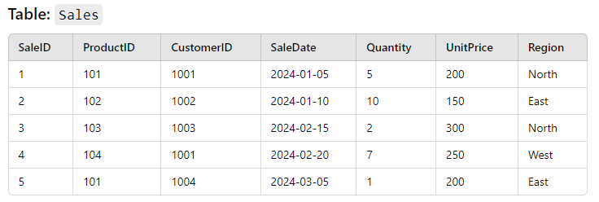

1. Write a query to calculate the total sales (Quantity * UnitPrice) for each product.

* select ProductID, UnitPrice*Quantity as "total sales amount" from sales;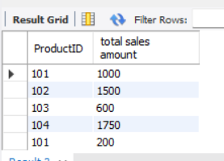

1. Write a query to find the total number of products sold in each region.

* select region ,sum(Quantity) from sales group by Region;
* 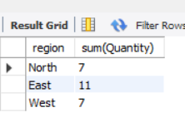

1. Write a query to get the average sales amount per product.

* select productID, (sum(quantity*unitprice)/sum(quantity)) as average_sales from sales groupby productID ;
* 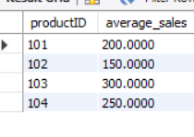

1. Find the regions where total sales are more than 3000.

* select region,sum(quantity*unitprice) as total_sales from sales group by region having
* total_sales >3000;
* 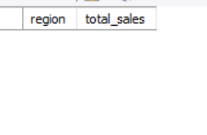

1. Write a query to get the maximum quantity sold for each product.

* select ProductID,sum(quantity) from sales group by productID;
* 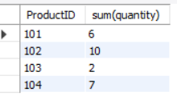

1. Write a query to calculate the average quantity of products sold per region.

* select ProductID,sum(quantity)/product*quantity from sales group by region;

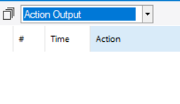

1. Find the product IDs that have generated a total sales amount of more than 1000.

* select ProductID,sum(quantity*unitprice) as total_sales from sales group by ProductID having
* total_sales >1000;
* 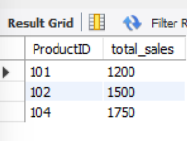

1. Write a query to get the total number of sales (rows) made for each customer.

* SELECT CustomerID, count(Quantity) as "total number of sales" from Sales
* GROUP BY CustomerID;

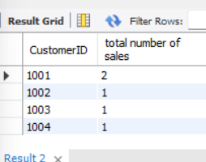

1. Find the products for which the average quantity sold is less than 5.

* SELECT ProductID, avg(quantity) as "average quantity sold" from Sales

Group BY ProductID

HAVING avg(quantity) < 5;

-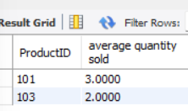

1. Write a query to find the sum of total sales for each customer in each region.

- SELECT CustomerID, Region, sum(Quantity * UnitPrice) as "Total Sales" from Sales

GROUP BY CustomerID, Region;

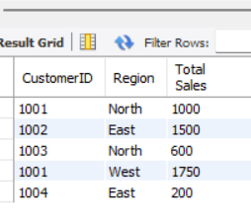

1. Write a query to calculate the total sales for each month.

* SELECT EXTRACT(MONTH FROM SaleDate) as month, sum(Quantity * UnitPrice) as "TotalSales" from Sales

GROUP BY EXTRACT(MONTH FROM SalesDate);

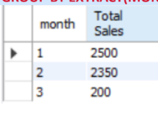

1. Find the regions where the average unit price is more than 200.

-SELECT Region, avg(UnitPrice) as "average unit price" from Sales

GROUP BY Region

HAVING avg(UnitPrice) > 200;

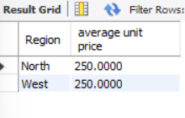

1. Write a query to get the minimum and maximum quantity sold per region

* Select Region, min(Quantity), max(Quantity) from Sales GROUP BY Region;

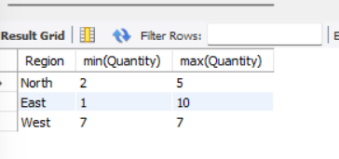

1. Find the customers who have made more than 2 purchases.

-SELECT CustomerID, count(ProductID) from sales

group by CustomerID

having count(ProductID) > 1;

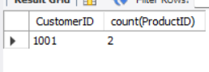

1. Write a query to find the total sales for each product and filter only those products where the total sales exceed 1500.

-SELECT ProductID, sum(Quantity * UnitPrice) as "total sales" from Sales

GROUP BY ProductID

HAVING sum(Quantity * UnitPrice) > 1500

;